Doug Strouth

CIS 228

City Jail Chapter 9

1)

Traditional:

SELECT C.CRIMINAL_ID, C.LAST, C.FIRST, CC.CRIME_CODE, CC.FINE_AMOUNT

FROM CRIMINALS C, CRIMES CR, CRIME_CHARGES CC

WHERE CR.CRIME_ID=CC.CRIME_ID

AND C.CRIMINAL_ID = CR.CRIMINAL_ID;

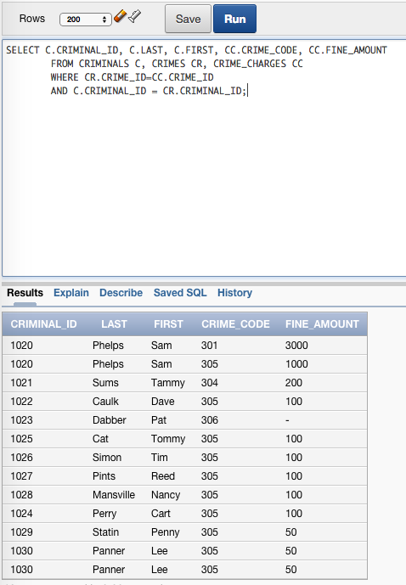

Join:

SELECT CRIMINAL_ID, LAST, FIRST, CRIME_CODE, FINE_AMOUNT

FROM CRIMINALS NATURAL JOIN CRIMES NATURAL JOIN CRIME_CHARGES;

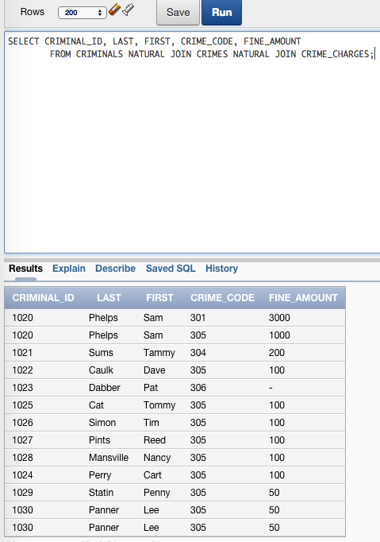

2) Traditional:

SELECT C.CRIMINAL_ID, C.LAST, C.FIRST, CR.CLASSIFICATION, CR.DATE_CHARGED, CR.CRIME_ID, A.FILING_DATE, A.STATUS

FROM CRIMINALS C, CRIMES CR, APPEALS A

WHERE C.CRIMINAL_ID=CR.CRIMINAL_ID

AND CR.CRIME_ID=A.CRIME_ID(+)

ORDER BY C.LAST;

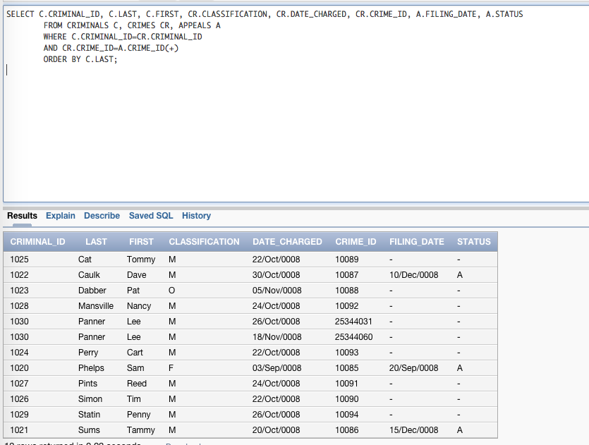

Join:

SELECT CRIMINAL_ID, LAST, FIRST,CLASSIFICATION, DATE_CHARGED, CRIME_ID, FILING_DATE, A.STATUS

FROM CRIMINALS NATURAL JOIN CRIMES LEFT OUTER JOIN APPEALS A

USING(CRIME_ID)

ORDER BY LAST;

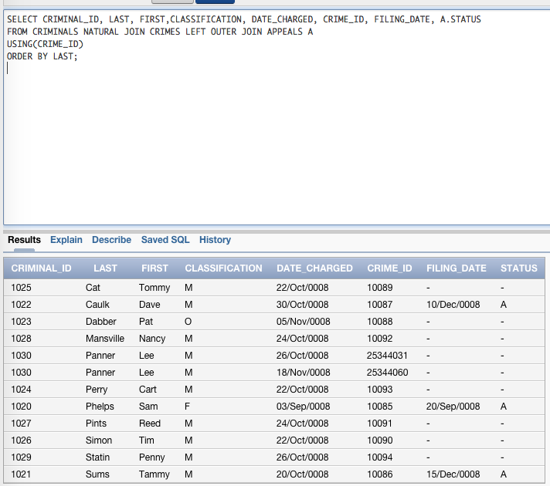

3) Traditional:

SELECT C.CRIMINAL_ID, C.LAST, C.FIRST, CR.CLASSIFICATION, CR.DATE_CHARGED, CC.CRIME_CODE, CC.FINE_AMOUNT

FROM CRIMINALS C, CRIMES CR, CRIME_CHARGES CC

WHERE CLASSIFICATION='O'

AND CR.CRIME_ID=CC.CRIME_ID

AND C.CRIMINAL_ID = CR.CRIMINAL_ID

ORDER BY CRIMINAL_ID, DATE_CHARGED;

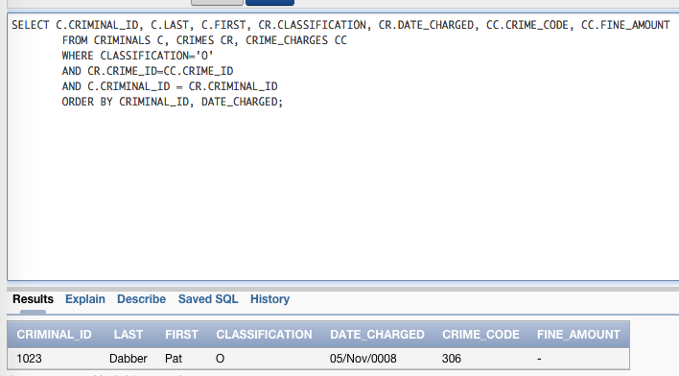

Join:

SELECT CRIMINAL_ID, LAST, FIRST, CLASSIFICATION, DATE_CHARGED, CRIME_CODE, FINE_AMOUNT

FROM CRIMINALS NATURAL JOIN CRIMES NATURAL JOIN CRIME_CHARGES

WHERE CLASSIFICATION='O';

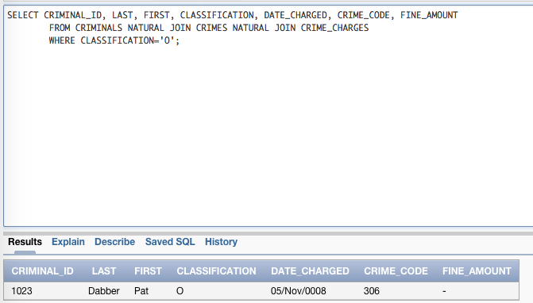

4) Traditional:

SELECT C.CRIMINAL_ID, C.LAST, C.FIRST, C.V_STATUS, C.P_STATUS, AL.ALIAS

FROM CRIMINALS C, ALIASES AL

WHERE C.CRIMINAL_ID=AL.CRIMINAL_ID(+)

ORDER BY LAST;

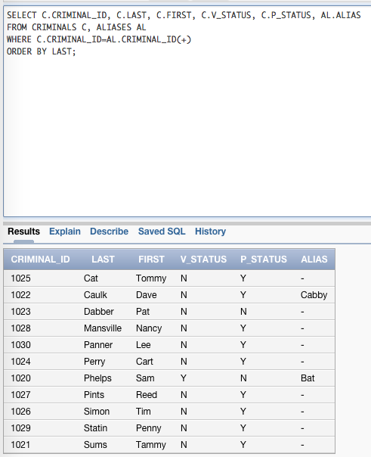

Join:

SELECT CRIMINAL_ID, LAST, FIRST, V_STATUS, P_STATUS, ALIAS

FROM CRIMINALS FULL OUTER JOIN ALIASES USING (CRIMINAL_ID)

ORDER BY LAST;

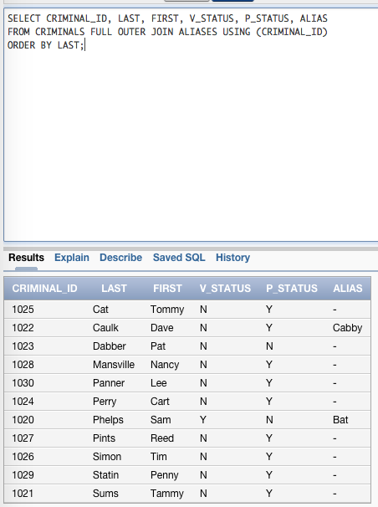

5) Traditional

SELECT C.LAST, C.FIRST, S.START_DATE, S.END_DATE, PR.CON_FREQ

FROM CRIMINALS C, PROB_CONTACT PR, SENTENCES S

WHERE C.CRIMINAL_ID=S.CRIMINAL_ID

AND S.TYPE='P'

AND (S.END_DATE - S.START_DATE) <= PR.HIGH_AMT

AND (S.END_DATE - S.START_DATE) >= PR.LOW_AMT

ORDER BY C.LAST, S.START_DATE;

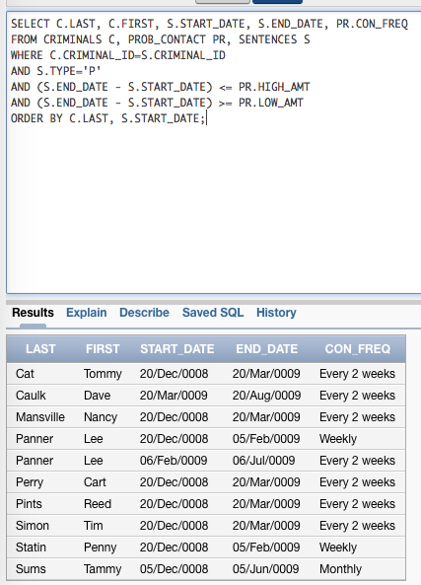

Join

6) Traditional:

SELECT PO.LAST, PO.FIRST, POM.LAST AS SUPERVISOR_LAST, POM.FIRST AS SUPERVISOR_FIRST

FROM PROB_OFFICERS PO, PROB_OFFICERS POM

WHERE PO.MGR_ID=POM.PROB_ID(+)

ORDER BY PO.LAST;

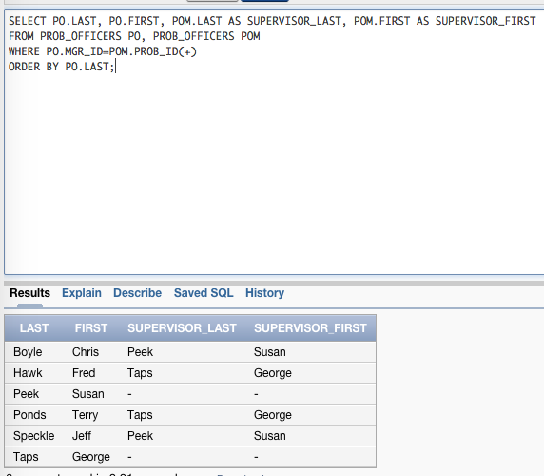

Join

SELECT PO.LAST, PO.FIRST, POM.LAST AS SUPERVISOR_LAST, POM.FIRST AS SUPERVISOR_FIRST

FROM PROB_OFFICERS PO LEFT OUTER JOIN PROB_OFFICERS POM

ON PO.MGR_ID=POM.PROB_ID

ORDER BY PO.LAST;

